**Sonoma County Healthcare Coalition – Completing Situation Reports & Resource Requests**

*LOCATION of SitRep and ResReq Quicksheets:*

* Coalition website: <https://sonomacounty.ca.gov/health-and-human-services/health-services/boards-commissions-and-committees/healthcare-coalition>
* Resource Bridge Document Hub

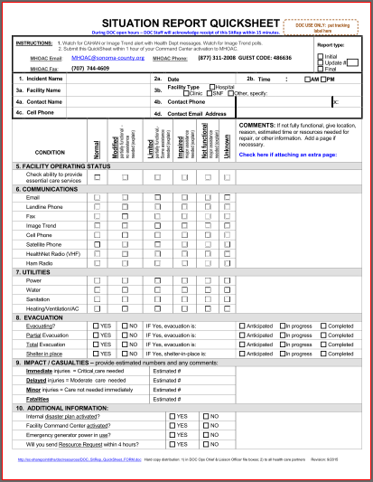

**Completing the Situation Report**

The Situation Report Quicksheet was developed by Sonoma County Health for local healthcare facilities to use when reporting their status to MHOAC Program (ie: the Health Department Operations Center, Health DOC). The Quicksheet is a distillation of only the essential questions that are asked in a 9-page SitRep compiled by MHOAC using individual facility SitReps to report overall local status to the State.

1. Read INSTRUCTIONS at top for when and how to submit your SitRep.
2. Top Right Corner – check if this is your first report, an update, or your final.
3. Answer all 10 questions and any sub-questions.
   1. Print LEGIBLY
   2. Most answers are checkmarks
   3. Fill in COMMENTS only when needed to describe your status
4. DOC will acknowledge receipt of SitReps so you only need to submit once.
5. NOTE: if you plan to request resources, you must first submit a SitRep.

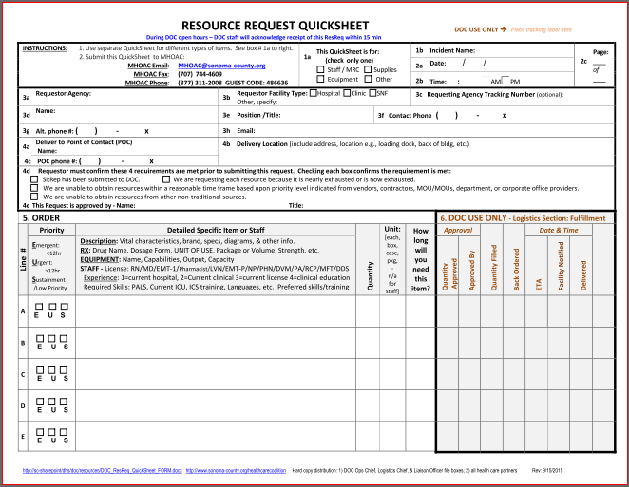**Completing the Resource Request**

The ResReq Quicksheet was developed by Sonoma County Health for local healthcare facilities to use when requesting resources from MHOAC Program.

1. Question 1a – use separate ResReqs for staff, for supplies, for equipment, or for other things. *WHY?:* 
   1. *Because you may have separate tracking #s for different items.*
   2. *Because delivery info is often different for different items.*
2. Answer all 5 questions and any sub-questions:
   1. Questions 3a-3h are about how to contact your Command Center for questions on your request.
   2. Questions 4a-4c are about the contact person for delivery or pickup of your items.
   3. Questions 4d-4e are critical. Check all boxes that apply, print the name & title of person in your facility approving the request to MHOAC.
   4. Question 5 provides the detail on what you are requesting. Provide as much detail as possible so that time is not lost trying to call you for more information.
3. DOC will acknowledge receipt of Resource Requests, so you only need to submit once.

S://PH/PHP/Committees/Healthcare Disaster Planning Forum/Coalition Products/SitRep&ResReq/Completing SitRep & ResReq Quicksheets.docx REV 4/2017